Retail Screen

Buttons and functions

1-Serach bar the search bar always default for the mouse cursor when a user use a scanner or type a barcode number it should bring up the item and display it in a display screen underneath

The look up button will bring up a 2nd display for the user to search the item by name or department or brand or family



2display screen is where all the items shows after the user scan them or manually use the touch display on a right to display the items

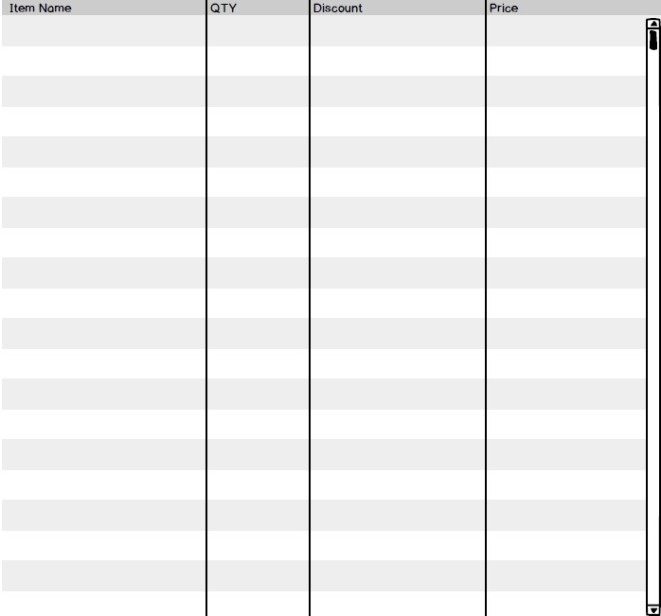

3- Touch buttons display

Is where the user can custom design the layout of the items he wants either fixed or by department or by brand it will display the items he want or group of items that can be displayed on there all done fro the touch-screen designer

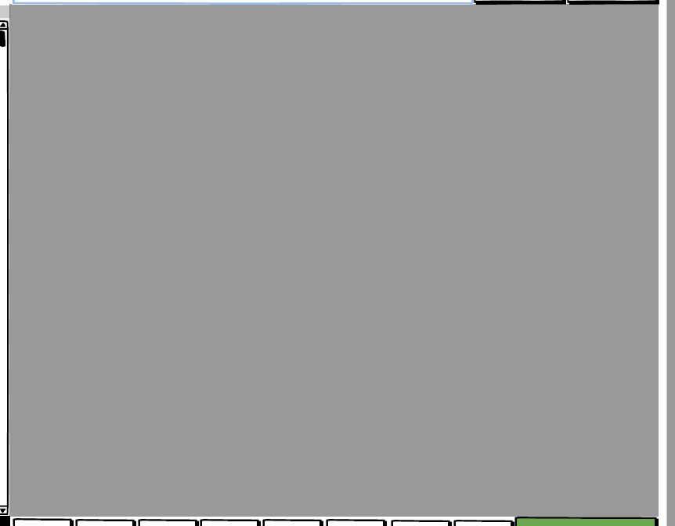

4- total and numers display section

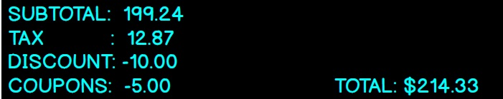

Subtotal is the total of the items that got scanned in a screen above along with a tax total

Discount and coupons cant be displayed unless they are used and applied by user

The total need to be bigger and cleaner make sure the background is black and font color is light

5- bottom buttons functions

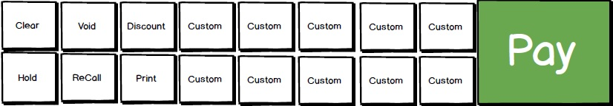

Clear button will clear everything on a item list screen

Void will be used when a user bring up a invoice and needs to void it

Hold is used when a user need to to put a scanned items on hold to be recalled later

The hold button it changes the text between hold and fetch when items not scanned it will display fetch and when user scans items the button will change to hold

Discount is used when a user need to give a discount on 1 item or the whole invoice

Recall is used when a user need to pull a paid or closed invoice before a screen will pull up with invoices list for the past hour or so

Print is used when a user need to prince a invoice

ALL custom buttons are used and changed by the user for anything he wants in a designer screen these are fixed functions the user can pick from a list of fixed functions to where they go and used and renamed

Pay screen is used when the user want to finish the transaction if pressed another screen will come up for the user to pick cash or credit card or anything listed he wants on there

When you design this screen please refer to the buttons I sent and the font I sent everything need to be clean cut clean code no bugs and light as possible